**Standard Work - Mobile App Release Process**

Version 1.1



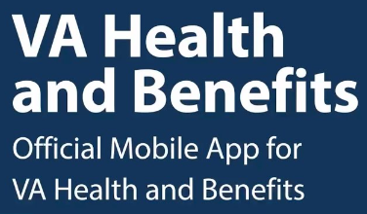

| Version | Author | Date | Comment |
| --- | --- | --- | --- |
| 1.0 | Adam Bischoff | 1/24/2023 | Initial Creation |
| 1.1 | Adam Bischoff | 3/7/2023 | App Store, Whats New In App, Call Center Guide inclusion |
|  |  |  |  |
|  |  |  |  |

**Purpose:**

Document is to provide steps, details, and information in the handling of release management within the VA Health and Benefits Mobile App Team.

This is a living document, so please update as needed while processes or refinements are made.

**Documents:**

* [Github Repository](https://github.com/department-of-veterans-affairs/va.gov-team/tree/master/products/va-mobile-app/releases)
* [Sprint and Release Calendar through EOY 2023](https://docs.google.com/spreadsheets/d/14jYcB3zhib3T9jyQjNpsfPLkAAqhLdAhXBPUQtsodgI/edit#gid=604215796)
* Past release tickets for example purposes
  + [1.40](https://github.com/department-of-veterans-affairs/va-mobile-app/issues/4669).0, [1.39.0](https://github.com/department-of-veterans-affairs/va-mobile-app/issues/4578), [1.36.0](https://github.com/department-of-veterans-affairs/va-mobile-app/issues/4423)
  + Can find others by searching in Slack with keywords Release or specific number

**Other:**

* Mainly requires a lot of coordination and communication amongst various parties (FE, both PMs, QA, VA PM, UX, etc)
* Not all releases are equal so there may be some differences between that requires extra communication or needs
* Access needed: Github, Zenhub, Digital Services @VA workspace
* You can close out Release tickets post release with no impact
* If VA PO is unable to approve the ticket, get another VA PO to approve and then have FE approve as they have Admin access
* If this document is updated, it needs to be re-uploaded to [Github Repository](https://github.com/department-of-veterans-affairs/va.gov-team/tree/master/products/va-mobile-app/releases)

**Contacts:**

* Release Owner - Adam Bischoff
* FE Engineering - Jon Bindbeutel
* QA - Tom Gammons
* VA PO - Chris Johnston

**High level processes**

1. Email and Github release ticket generated and sent to Release Owner
2. Release Owner Reviews and Preps Github Release Ticket
3. Release Owner creates Release Thread in Slack Digital Services @ VA (DSVA) slack channel called va-mobile-app
4. Get Ad Hoc Sign Offs - QA and Product
5. In Slack, ask VA PO for approval
6. After VA PO approves, systematically the release will be completed
   1. PO approver has to had admin access
   2. If not, one option is to have FE engineering admin approve only after the PO has made an approval comment on the ticket
7. App Store Changes - What's New Section, Content, Images
8. What’s New In App Changes
9. Call Center Documentation

**Steps for Email and Github release ticket generated and sent to Release Owner**

1. **Owner of the process will receive an email indicating a ticket has been generated for the release**
   1. 
   2. 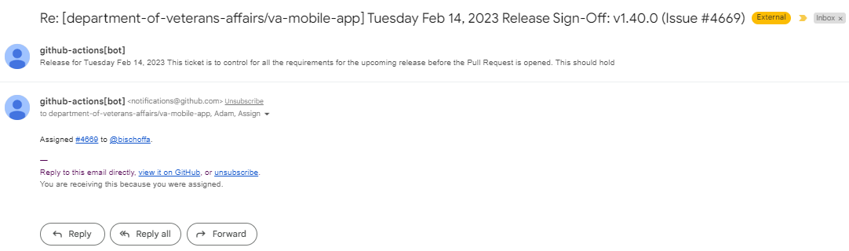

**Steps for Release Owner Reviews and Preps Github Release Ticket**

1. **Click the ticket number link in the email to go to the ticket in Github/Zenhub**
2. **Review the ticket prefilled information** 
   1. Work on the ticket will be done over time and not something that can be resolved right now
   2. Verify release and [dates](https://docs.google.com/spreadsheets/d/14jYcB3zhib3T9jyQjNpsfPLkAAqhLdAhXBPUQtsodgI/edit#gid=604215796) are correct
   3. Sections
      1. Descriptor
      2. Release Checklist  
         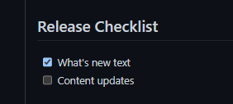
      3. Sign-offs  
         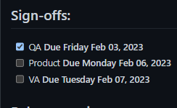
      4. Release Version  
         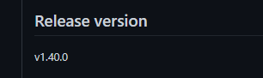
      5. What’s New Content
      6. App Store Content Changes  
         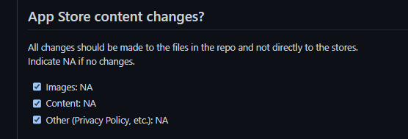
      7. Severe Bugs
         1. 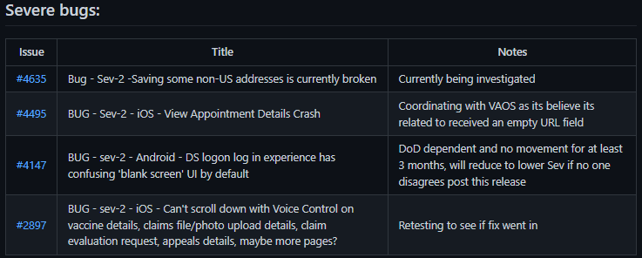
      8. Regression Testing -
         1. Ignore, QA will post testing results in the comments section
3. **In the comments section post the Release Report from Zenhub**
   1. [Link](https://app.zenhub.com/workspaces/va-mobile-product-view-610035bc5395bb000e62e529/reports/release?release=Z2lkOi8vcmFwdG9yL1JlbGVhc2UvODQ5MTM) to Release Report - select your report from the drop down
   2. 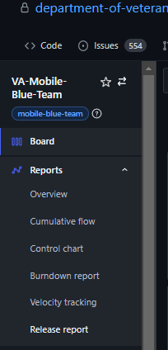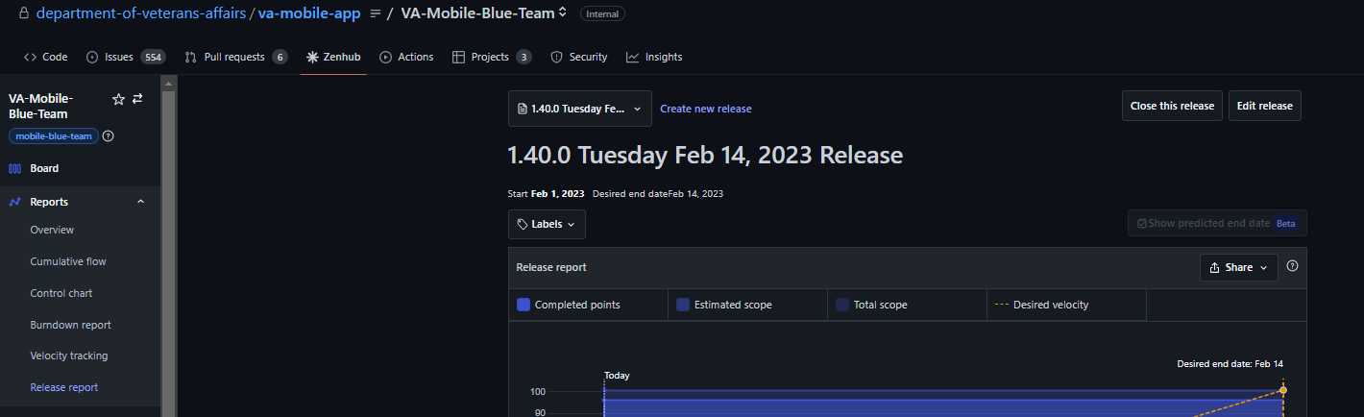
4. **In comments section, paste the images of the tickets associated with the release** 
   1. 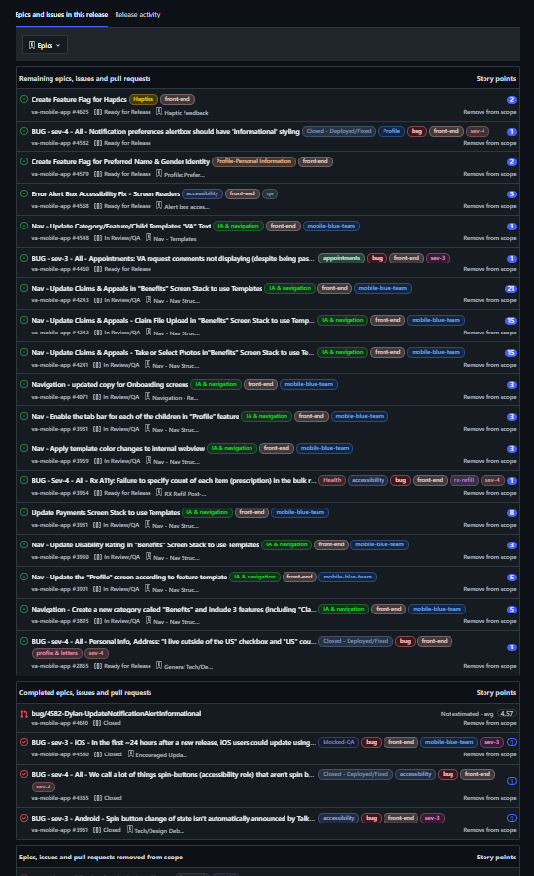
   2. This shows all tickets in their current state, what is releasing is the bottom section Completed epics, etc ; its likely those in the incomplete state get moved for the completed state during this process
5. **Review tickets to see if OS App Stores need an updated Whats New section or images**
   1. There are *two* options
      1. No major changes - just bug fixes
         1. Update Whats New content section
            1. “We added general improvements and fixed a few bugs.”
         2. Update App Store content changes section
            1. Checkbox and NA for Images, Content, and Other
      2. Big app changes including feature releases - this is not required now, only need it prior to VA PO signoff
         1. May mean new copy is needed for App Store’s Whats New Content along with image changes
         2. Coordinate with PM of the work to get images and copy
         3. Will need to coordinate with PM on [this process](https://docs.google.com/document/d/1luRRb94AJZpqs5pp7pxWbuHakHXT9FZHe8QNihzDtog/edit#heading=h.mnq6vtjqteg4) 
            1. Note: Process established by past agency so may be new or rusty for many
         4. Once completed Checkbox the Release Checklist and the App Store content changes section
6. **Severe Bugs update**
   1. Click each bug and see the latest status of the bug
      1. If none in the comment section of ticket, reach out to FE Engineer
      2. May find a ticket is blocked from an external factor and may need to work with QA to see if the Sev-2 bug should be reclassified
   2. Edit the ticket and put an updated status on the bug

**Steps - Slack Communication for Release**

1. **Go to DVSA va-mobile-app Channel** 
   1. 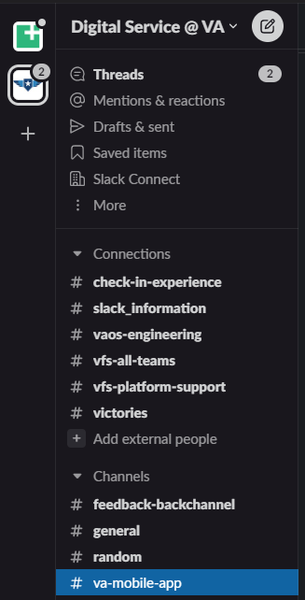
2. **In that channel create a thread by typing “Release X.XX.X Coordination (spool emoji)**
   1. Release 1.40.0 Coordination :thread:
   2. 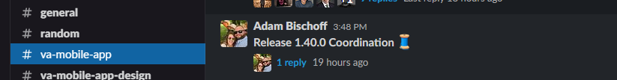
3. **After posting that message click it and post a reply message** 
   1. 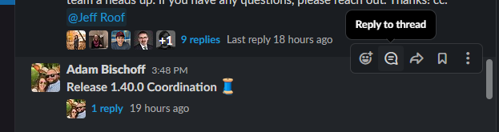
4. **Post something like this in the reply**

Release Ticket #XXXX (update ticket number and link url to ticket)

Release Report: here (link url to Github release report)

Sign Off Timing (copy paste them from the ticket)

- QA Due Friday Feb 03, 2023

- Product Due Monday Feb 06, 2023

- VA Due Tuesday Feb 07, 2023

Contacts:

QA - @TomGammons (QA Lead)

Engineering - @Jon Bindbeutel (FE Lead)

@Jon Bindbeutel if you can confirm all applicable tickets are tagged with release.

* 1. 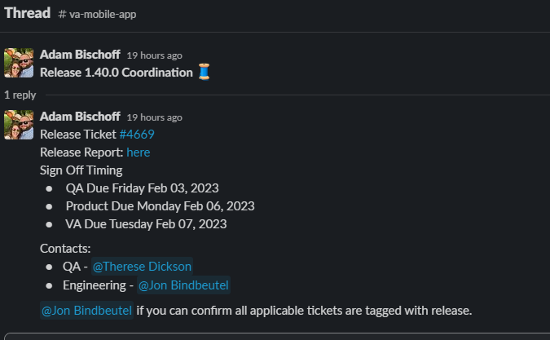

**Steps Get Ad Hoc Sign Offs - QA and Product**

1. **QA should be performing there testing on these tickets**
2. **QA will post their approval in Slack and also update the release ticket with testing results**
   1. QA ideally should get their testing done by the date associated with the ticket however there is some wiggle room, technically can wait till day of VA approval but ideally want it sooner
   2. Delays may happen to to testing issues, resources, or upstream blockers so if no update by EOD QA due date, follow up with QA Release contact and work with them accordingly
3. **Once QA is approved, Release PM will need to sign off**
   1. Verify all the release ticket information is completed and fill out (checkboxes, Whats New copy, Whats New images, etc)
   2. See if there any concerns or risk that need to be addressed
4. **Once PM is approved then click that check box on the ticket**

**Steps Ask VA PO for approval in Slack**

1. **This must be done on the day of their due date, cannot be done early due to system automation issues**
2. **In the Release Thread in DVSA va-mobile-app channel post something like**

Hey @ VA PO , this release is ready for you sign off. If you have any questions please let me know.

The release contains bug fixes and general updates, no new feature delivery. CC: @ Release PM backup

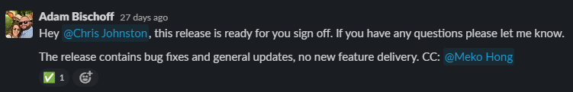

1. **VA PM will approve it in a way the system will systematically kick off the release build and process** 
   1. 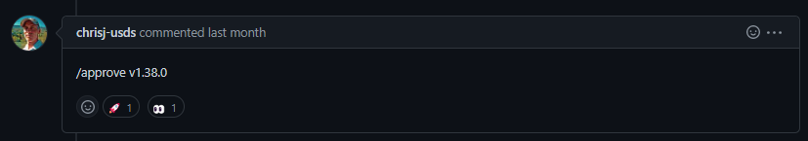

**App Store Changes - What's New Section, Content, Images**

* Product Leads will have determined for the release of their feature, enhancement, product if App store changes are necessary by creating tickets and having the tickets done before release
  + Product Leads are responsible for actual content
  + If not tickets then no changes to Content, Images, and likely use the generic bugs language for the App Store’s What’s New
  + If any of these items need changed from what is currently in the app store to something different PRs will be needed
* Release Lead responsible for implementing
  + In the event there are multiple things being released with content for In App Content then Release Lead will coordinate with Product Leads and Copy for unified content
  + For specific steps use [this document](https://docs.google.com/document/d/1luRRb94AJZpqs5pp7pxWbuHakHXT9FZHe8QNihzDtog/edit)

**What’s New In App Changes**

* Product Leads will have determined for the release of their feature, enhancement, product if App store changes are necessary by creating tickets and having the tickets done before release
  + Product Leads are responsible for actual content
  + If not tickets then no changes to Content, Images, and likely use the generic bugs language for the App Store’s What’s New
  + If any of these items need changed from what is currently in the app store to something different PRs will be needed
* Release Lead responsible for implementing
  + In the event there are multiple things being released with content for Whats New In App then Release Lead will coordinate with Product Leads and Copy for unified content

**Call Center Documentation**

* Product Leads will have determined for the release of their feature, enhancement, product requires changes to the VA’s Call Center Documentation
  + Product Leads are responsible for actual content
  + If there is no ticket then there is no update
* Release Lead is responsible for updating Call Center Guide
  + In the event there are multiple things being released with updates to the Call Center Guide then will need to coordinate with Product Leads for a unified Call Center Guide
  + For specific steps follow [this document](https://github.com/department-of-veterans-affairs/va.gov-team/blob/master/platform/contact-center/request-contact-center-review.md) 
    - Interaction is currently with Stephen/Steven who may tweak what Mobile sends and share that accordingly with the call center
    - Ask for the latest copy they have so we have the latest version with the latest changes